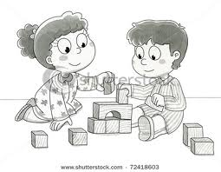

FUN, OPTIONAL EXTENSIONS FOR AT HOME:
Draw and write about your favorite part of a story.
Practice counting how many spoons, forks, etc you need for dinner.
Ms. Boudreau’s
Home/School Connection
A newsletter connecting home and school environments
http://Jenniferboudreau.weebly.com

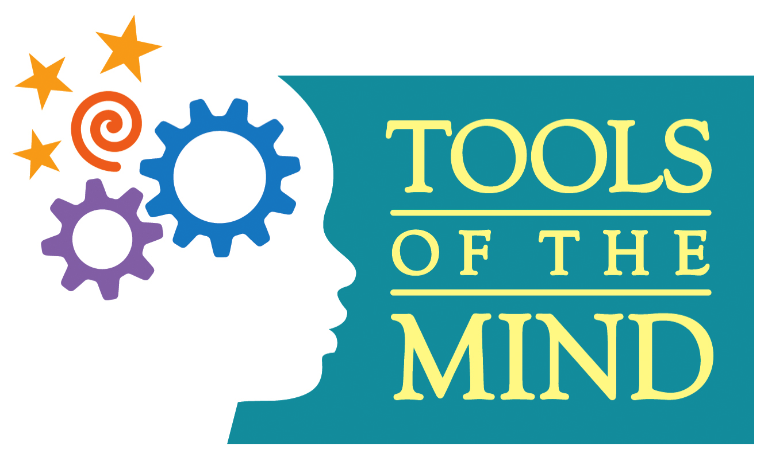
ISSUE # 1 Page 1
Date: Sept. 7, 2017
CALENDAR REMINDERS
School Calendar Can be found at http://aes.seekonk.sharpschool.com/calendar
Sept 22nd- Ms. Boudreau’s Scholastic Book Order Due

Birthdays
Baron- Sept 22
Mrs. Pereira- Sept. 22

Welcome to Kindergarten! I hope you had a terrific summer and are excited about the upcoming school year! Your child is special to you, and to me, and I hope to form a partnership with you as the year progresses. Please be sure to email, call or send a note if you have any questions or concerns. Remember we want to catch issues when they are snowflakes and not snowballs! ☺
Each Friday, you will be receiving a newsletter from me designed to give you information about what we are doing in school and give you ideas of activities you can do at home with your child. I will highlight some activities and key ideas of the curriculum to give you a picture of a day in the life of your kindergartner.
Studies show that the best foundation for children is to use play as the activity to ‘spark’ learning. When you ask your children what they did in school, their answer will most likely be ‘I played’, and they will be absolutely right as much of what they learn in September will happen through games and play. A part of this newsletter, titled “What are we doing in school?” will tell you about the theme we are working on and what your child is learning through play.

WHAT ARE WE DOING IN SCHOOL?
Theme: Welcome to Kindergarten
What’s happening: We began to open our centers. We learned how to use the library, 2 manipulative centers and the writing/art center. We learned how to care for our classroom materials: pencils, crayons, markers, whiteboards, dry erase markers, erasers (socks), magnets, chairs, snacks, and MORE! We sure did a lot in 4 days!
What Reading & Writing Skills are being practiced? We practiced listening to a story and sharing our favorite part of the book. We wrote plans before we worked. As the students write, they will be learning about letters and sounds. We have practiced writing lines where our words would be. As we move along, you will see the children begin to fill in beginning sounds/letter for words. I will explain more at Parent/Teacher conferences. A sign-up sheet for conferences will come home next week.
What Math Skills are being practiced? We explored basic shapes, length, counting a set of objects and how to share materials with partners.

Wish List Items

*Double Sided Tape
* Seasonal Stickers

Classroom Staff:
Kindergarten Teacher:
Ms. Boudreau
Instructional Aide: Mrs. Pereira

Web Site

http://jenniferboudreau.weebly.com

Take a Peek!
THIS IS THE LAST PAPER NEWSLETTER TO COME HOME! I HAVE & WILL SEND THE NEWSLETTERS VIA EMAIL. IF YOU HAVE NOT RECEIVED AN EMAIL FROM ME, PLEASE LET ME KNOW SO WE CAN FIX IT FOR YOU. NEXT WEEKS NEWSLETTER WILL BE EMAILED- NO PAPER COPY. NEWSLETTERS ARE ALWAYS ON THE WEB. SITE.
Ms. Boudreau’s
Home/School Connection
A newsletter connecting home and school environments: Page 2
Snack: Please remember to send in one small, healthy snack each day. Remember to provide eating utensils, straws, napkins, etc. as needed. Also, remember we are a NUT free room for snack. Please read all labels carefully to be sure there are no nuts or nut products and that the food is NOT PRODUCED IN ANY KIND OF NUT FACILITY. You can also help by having your child practice opening containers, taking wrappers off straws, and placing straws in one’s own juice box/pouch (boxes are easier than pouches). Thank you for all your help!

Book Order: The Scholastic Book Order is Due by Friday, Sept 22nd. If you wish to order, you can order in paper form by sending in the order form & a CHECK made out to Scholastic. Or, you can order online at www.scholastic.com and our class code is GPD3G. All orders help us earn free books for our classroom.

Birthdays: Remember, we will only send home invitations in school if ALL the children in the class are invited or if ALL GIRLS or ALL BOYS are invited. We do not want any hurt feelings! Currently, there are 23 Kindergarten students….11 girls and 12 boys. NO food treats are allowed to be send in for in-class birthday celebrations. If you would like to send in something for your child to share, you can send it pencils, stickers, or other small items. You do not have to send in anything, the latter are suggestions only. PLEASE REMEMBER, NO FOOD!

End Notes: I have a green fabric Seekonk Parks and Rec Bag someone sent supplies in on the 1st day of school. No child will claim it as his/hers. If it belongs to your family, just send me an email and let me know and I will be happy to return it to you.
Please be sure to sign and submit the online Technology form that was emailed to you by the school (not from my email) so your child can use the technology that the classroom and school has to offer. Thank you!

Food for Thought…
an excerpt from an educational article
Parent’s Guide to Preparing Your Child for School
What is School Readiness?
You should allow your child to have the kind of experiences that will help him/her do well in school at an early age. “School Readiness” means making sure your child has the academic, social, independence, and communication skills required to successfully start school. Reading, talking, and playing with others will help your child prepare for his/her school career.
- Part 1 : Independence:
Children feel good about themselves when they learn how to zip their coats or tie their shoes. Their self-esteem is built by doing these things on their own. In school, children have to know how to do some things themselves. To help your child become more independent, you can:
~Buy shoes and clothes that are easy for your child to buckle, zip and fasten.
~Teach your child how to dress him/herself.
~Have your child do easy chores like setting the table or picking up toys.
~Make sure your child is potty trained and is taught good hand washing.
~Let your child finish puzzles or other activities on his or her own.

