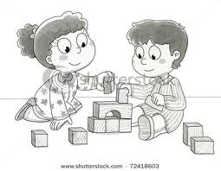

*WISH LIST*

*\* Zip lock Bags of all sizes*

*\* Cleaning Wipes*

*Thank You!*

Jack and Annie had quite the adventure in the Ice Age! They had an interaction with a Sabertooth Tiger and a Wooly Mammoth!

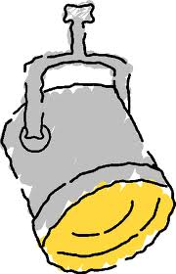**Spotlight Activity: Individualized Reading!**

I am now using leveled readers with children during our reading buddies time. This allows all each child to read at his/her own level. The children read with a buddy who is at the same level. Buddies help each other with strategies and decoding. We are focusing on decoding and comprehension as well as practicing reading fluency. Children also have access to these leveled readers during Buddy Reading so they can practice at various times of the day. The strategies we use to read are 1) Have I seen this word before? 2) Can I build a word? Or 3) Does it make sense with what I am reading?

**CALENDAR REMINDERS**

Feb 17-21 Feb Vacation

Feb. Birthdays

Feb 5- Ryan

FALL ISSUE # 22

Date: Feb. 14, 2020

**WEB CONNECTIONS**

[**http://jenniferboudreau.weebly.com**](http://jenniferboudreau.weebly.com)

*Try these games…*

*Math- Corners and Sides*

*ELA- Word Making*

**EXTENSIONS AT HOME:**

* Use cereal or small pasta to make groups of five. After making several groups of 5, have your child count the pasta by skip counting by 5’s.
* Children should read to you and you to them every night!
* When reading at home, ask your child to think about the strategies discussed above when they are reading and get “stuck.”

**WHAT ARE WE DOING IN SCHOOL?**

Theme: The Ice Age- Sunset of the Sabertooth

What’s happening in centers: Children are becoming very proficient at the routine of the new centers. They are learning to work both independently and with their classmates to get their work done.

What Reading & Writing Skills are being practiced? In centers, the children continue to practice integral literacy skills, self-regulation, and good work habits. Reading and writing continues to be practiced multiple times per day. Children are asked to practice individual skills in centers and put them all together when reading and writing!

What Math Skills are being practiced? We are working on solving comparison number stories and “proving” their solutions. We represent and compare teen numbers and learn about the equal symbol.

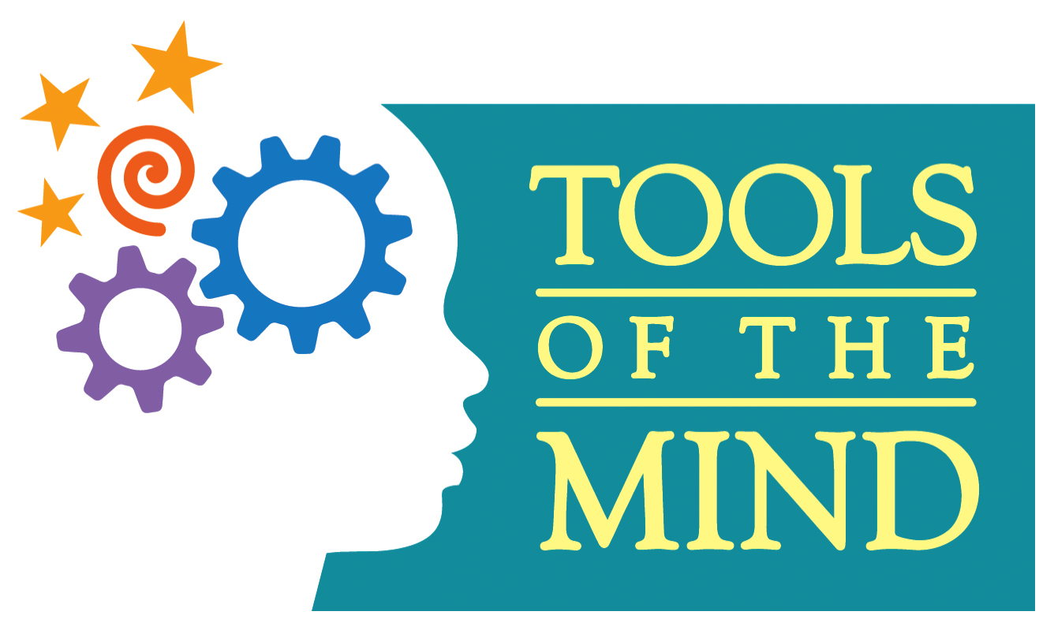

Ms. Boudreau’s Home/School Connection

A newsletter connecting home and school environments

http://jenniferboudreau.weebly.com