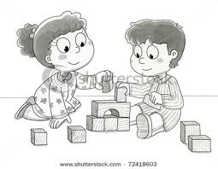

**WISH LIST:**

* “Skinny” grip black dry erase markers
* Cleaning Wipes

Thank you!

.

Newsletters are emailed each Friday & are posted on the class website. **http://jenniferboudreau.weebly.com**

From the Teacher’s Desk: It’s already week 2 of kindergarten! During the first several weeks of school, we will lay the foundation for a happy, successful Kindergarten year! The children will develop a sense of community through games, songs and activities. They will gradually become familiar with the daily routine, classroom centers and materials, and the school rules. This kindergarten will be our Kindergarten, and the children will work together to make it their own. I look forward to getting to know all of the children and families as the school year progresses.

Supplies: Please be sure your child brings a backpack to school every day. It is needed to transport his/her kindergarten folder, papers and projects to and from school. Empty the folder each day. Also, be sure to write your child’s name or initials on EVERYTHING he/she brings to school. The inside tag of hats, mittens, coats, sweaters, sweatshirts, snack bags etc. is a great place for your child’s name. Labeling helps me promptly return any “lost” items.

Box Tops for Education: Our class collects BOX TOPS FOR EDUCATION. Please feel free to send these in as you collect them-ANYIME. Place box tops in a plastic bag or an envelope so we avoid little slips of paper falling about our cubby area. I know they started to do ones where you scan the receipt online, but if you have any paper ones, we still take those too!

Three Little Things That Help A Lot:

1. Please encourage your child to use the bathroom ***just prior*** to leaving for school. Please ask your child -care provider to ask your child to go if your child is with someone else before school. This helps cut down on bathroom trips during our opening group activities.

2. Please try to limit the small objects that are worn to school (bracelets, watches, necklaces...), items that come to school in pockets (money, small toys, trading cards...) and items that are clipped to or are inside backpacks. These items often become distractions to your child’s learning.

3. Tie shoelaces in double knots.

**Web Site:**

**Look for new pictures under the “Pictures 19-20” tab!!!!**

**http://jenniferboudreau.weebly.com**

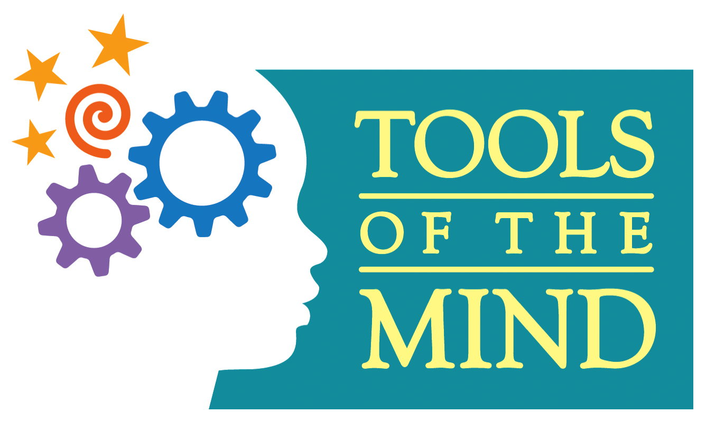

Ms. Boudreau’s

Home/School Connection

A newsletter connecting home and school environments

**http://jenniferboudreau.weebly.com**

ISSUE # 2, Page 1

Date: Sept. 6, 2019

**

**CALENDAR REMINDERS**

*School Calendar Can be found at* [*http://aes.seekonk.sharpschool.com/calendar*](http://aes.seekonk.sharpschool.com/calendar)

*Birthdays*

*Luke- Sept. 4*

*Jaxson C.- Sept. 14*

*Mrs. Pereira- Sept 22*

*Travis-Sept. 23*

**CALENDAR REMINDERS**

*School Calendar Can be found at* [*http://aes.seekonk.sharpschool.com/calendar*](http://aes.seekonk.sharpschool.com/calendar)

**Web Site:**

**Look for new pictures under the “Pictures 19-20” tab!!!!**

**http://jenniferboudreau.weebly.com**

End Note:

The students worked collaboratively to generate, sort and

create a set of classroom rules. They are proud of their rules!

1. Stay Safe.

2) Treat others kindly.

3) Always do your best.

4) Respect people and things.

And when on the rug or at our tables, we know….

Everybody Look

Everybody Listen

Everybody Quiet

Everybody Sitting

Everybody Thinking

**WISH LIST:**

* “Skinny” grip black dry erase markers

* Cleaning Wipes

Thank You!

.

Ms. Boudreau’s

Home/School Connection

A newsletter connecting home and school environments

**EXTENSIONS AT HOME:**

* Draw and write about your favorite part of a story.
* Practice counting how many spoons, forks, etc you need for dinner.

**WHAT ARE WE DOING IN SCHOOL?**

Theme: Fairy Tales – *The Three Little Pigs*.

What’s happening in centers: We are acting out the fairy tales we read to learn about story sequence and characters. We are practicing taking turns and changing roles. We are learning to use the comprehension strategies we have learned to act out our roles.

What Reading & Writing Skills are being practiced? We practice visualizing or making a picture of the story in our minds. We are learning to think about character empathy or how the characters in the story feel. We also talk about story grammar or the beginning, middle and end of the story. We write plans before we act. As the students do all this writing, they will be learning about letters and sounds.

What Math Skills are being practiced? We are practicing recognizing numbers, orally counting, orally counting on from a number, & counting and comparing data about birthdays!

ISSUE # 2, Page 2

Date: Sept. 6, 2019

**