

**WHAT ARE WE DOING IN SCHOOL?**

Theme: The Old West- Ghost Town at Sundown

What’s happening in centers: The students have become experts at using the center-planning chart! They to know what center to go to and know what icon to look for to determine if they will be reading with me on a particular day.

Thank you so much for taking such wonderful care of the books that come home each week and for sending them back the next day! I ***truly*** appreciate your care with these books!

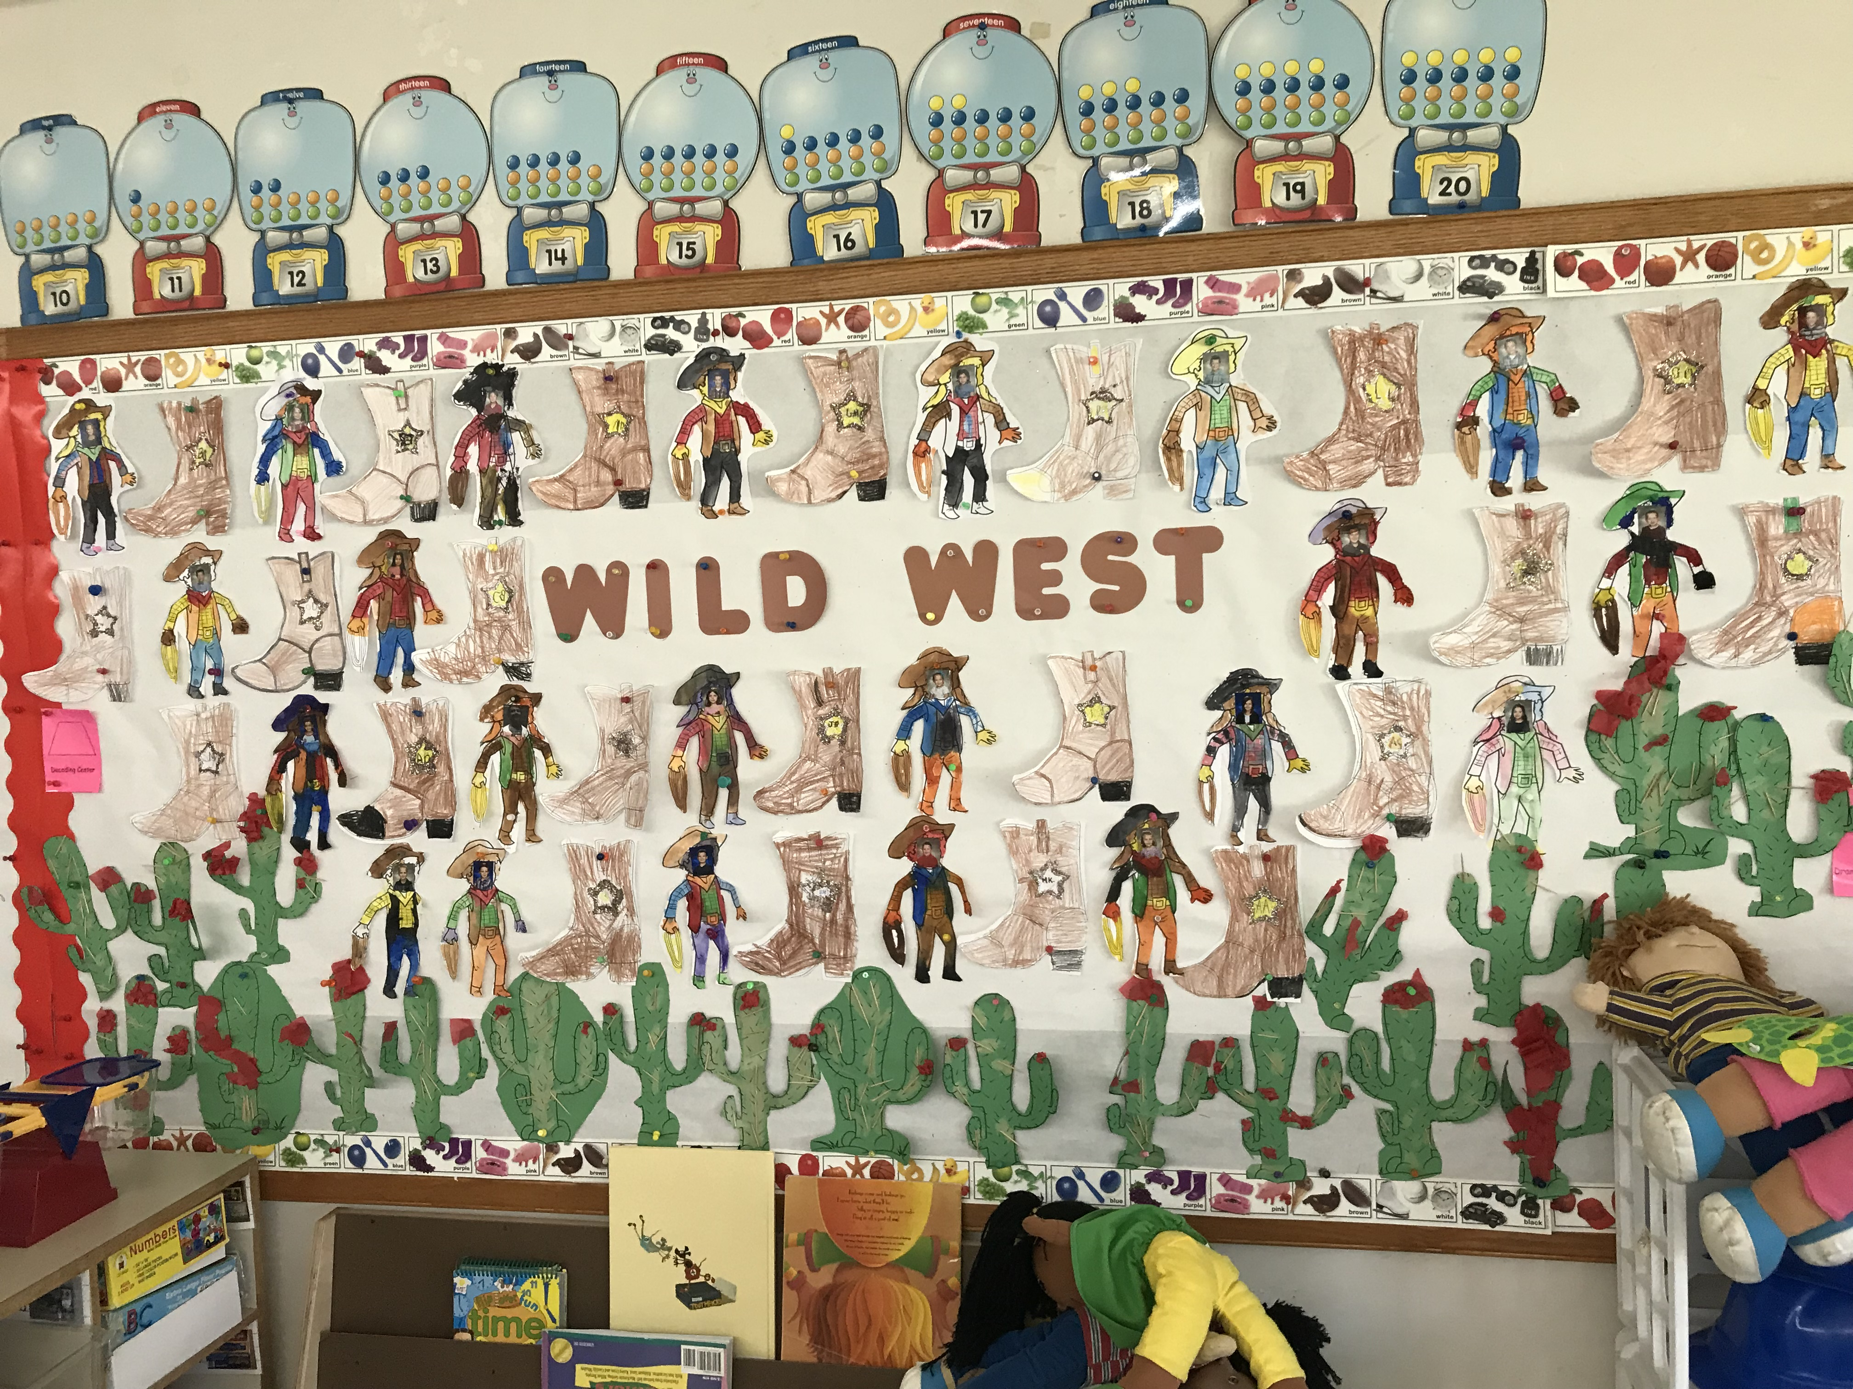

**Have any neat websites to share with the class? We LOVE hearing about new resources for learning? Email me at** [**boudreauj@seekonkschools.org**](mailto:boudreauj@seekonkschools.org) **, and I can share them in future newsletters! ☺**

**CALENDAR REMINDERS**

June 20th Last Day of School- Early Release

April Birthdays

April 3rd- Jackson

*WISH LIST*

*\* Colored Duct Tape*

*\* Highlighters-any color*

***Thank you!***

NOTES FROM THE TEACHER…

Jack and Annie’s adventure is taking place in an early American ghost town. Can you believe we are already on book 10?

* Howdy from the OLD WEST! This week, Jack and Annie began their adventure in an early American ghost town. They are looking for the second clue to Morgan’s riddle….

**EXTENSIONS AT HOME:**

* Write your alphabet from A to Z and from a to z.

* Count from 1-100 for everyone in your family!

*

Spring ISSUE # 31

Date: April 27, 2018

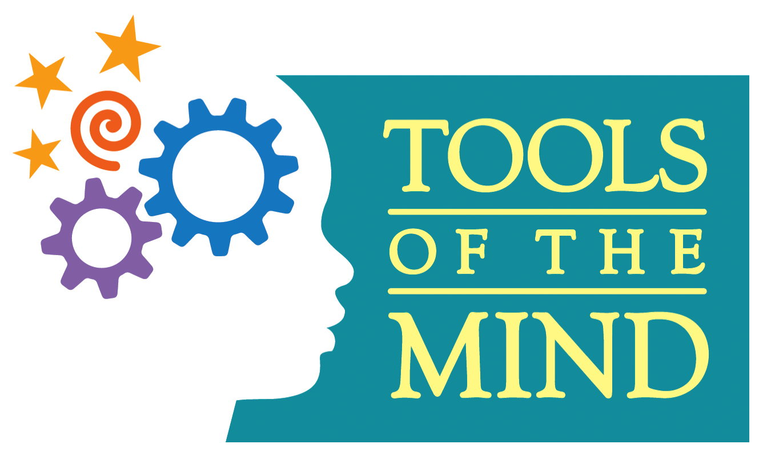

Ms. Boudreau’s Home/School Connection

A newsletter connecting home and school environments

Website: Jenniferboudreau.weebly.com